淡江大學2019-2020年英歐語組姊妹校

交換生聯合甄選作業簡章

2019-2020 Tamkang University Exchange Students Application and Selection Guide (English, French, German, Spanish and Russian Groups)

附件1＿2019-2020英歐語組姊妹校交換學校一覽表2019-2020 Tamkang University Exchange Program Information of Partner Universities (English, French, German, Spanish and Russian Groups)
附件5＿保證書Letter of Guarantee
附件6＿交換生申請Q&A Exchange Student Application Q&A

本簡章及其附件請逕至本處網站詳閱http://www.oieie.tku.edu.tw/
有問題歡迎逕向本處辦公室（T1006）各承辦人洽詢：
歐、美、大洋洲：朱心瑩（校內分機2002）、日本：顏嘉慧（校內分機2002)
亞洲地區（除大陸及日本以外）：楊鳳僊（校內分機2003）
This guide can be found on OICSA’s website: http://www.oieie.tku.edu.tw/
If you have any queries, please contact our office (T1006):
Europe, America and Oceania: Acid (Ext. 2002) Japan: Chiahui (Ext. 2002)
Asia (Excluding Mainland China and Japan): Dolly (Ext. 2003)
- 申請資格及相關規定Eligibility & Related Regulations
一、申請資格Eligibility
（一）本校大學部二年級、三年級及碩士班在學學生；三年級學生可申請於大四上學期至部份姊妹校交換留學。
Applicants must be a sophomore or junior student or a master’s student; junior students can apply for exchange to certain partner universities during first semester in their senior year.
（二）學生在校學業成績總平均75分以上或系成績百分比前40%（研究所一年級學生應檢附大學四年成績單）；經所屬系、所、院初選通過，並獲推薦者。
Applicants need to have an average grade of 75 or top 40% of the department (Please refer to the transcripts), no grade requirement for master students (first-year master students should attach undergraduate transcripts). Applicants must be recommended by the department and college.
（三）語言能力檢定合格者Language proficiency qualification
１、英語組須檢附托福iBT 70分以上，或IELTS 5.5（學術組）成績証明，如各姊妹校另有規定請依各校規定檢附。
English group must attach certificates of TOEFL iBT 70 or IELTS 5.5 (academic). If partner universities have other regulations, please follow theirs accordingly.
２、赴法、德、西、俄語組須檢附該種語文之語言能力證明：法語組(B1)；德語組(A2)；西文組(B1)；俄語組(TORFL: Level 2)，以助甄選資格審查。
French, German, Spaish and Russian Groups must attach certificates: French (B1); German (A2); Spanihs (B1) and Russian (TORFL: Level 2), to assist in the selection process.
二、相關規定 Relevant Regulations
為顧及學生在當地留學時安全，請家長與學生主動配合告知有無曾經受身心重大疾病之就診紀錄。In order to ensure the safety of students when studying abroad, parents and students shall take the initiative to inform the school if there are major physical or mental illness treatment records.
- 申請及甄選注意事項 Notices for Application and Selection
一、申請日期：即日起至3月20日（星期三）下午5時止。
Application Period: 5th November (Monday) to 19th November (Monday) 17:00
二、申請方式 How to apply
（一）書面申請Applying on Paper
申請人請選定申請組別（限一組），並備齊應繳文件，經所屬系所、學院初審合格及推薦後，統一由系上送件至國際處。
Applicants must select a group to apply (limited to one group) and prepare required documents. Applicants must be recommended by their departments and colleges and submit the applications to the Office of International and Cross-Strait Affairs (OICSA).
（二）申請應繳文件Required Documents
１、申請表（需親筆簽名、系主任簽名）
Application form (to be signed by the applicant and head of department)
２、本校中文歷年成績單正本
Original copy of transcripts in Chinese
３、語文能力證明文件（影本或網路成績列表，正本於面試時繳交驗核）
Language proficiency certifications (Photocopied or online transcripts, original document should be handed in during oral interview for verifications)
４、授課老師推薦函1封（請使用中文或依申請語言組別撰寫）
1 letters of recommendation from professors (written in Chinese or the language of chosen group)
５、中文及外文自傳（依申請語言組別撰寫）
Chinese and the foreign language autobiography (depending on chosen group)
６、中文及外文研習計畫書（依申請語言組別撰寫）
Chinese and the foreign language study plan (depending on chosen group)
７、保證書（附件5）
Letter of guarantee (attachment 5)
８、其他相關有助甄選資格審查之證明文件資料影本（可縮印使用；正本備查）
Other relevant photocopies of certifications that assist in the selection process (can be printed in reduced format; original copy will be used for future reference)
※資料不超過16頁，單面列印，並請統一以A4格式製作（成績單及語言能力證明可用原格式），依序整理，不必裝訂，以單層L型塑膠講義套送件 (資料不齊全者不予受理)。
※Documents must not exceed 16 pages. It has to be printed one sided in A4 (transcripts and language proficiency qualifications can be used in its original format) and placed in order. No binding is required. A project folder shall be used for delivery. (Incomplete documents will not be accepted).
（三）如何填寫姊妹校志願How to Mark Choices of Partner Universities
請於申請表依序填上志願學校，不限定志願數。將依甄選成績及所填志願之先後順序分發，請詳加考慮並慎重填寫。
In the application form, applicants shall mark the university choices in order of their universities priorities. There are no limits to the number of choices. Applicants will be distributed in accordance with the selection results and their university priorities. Please consider carefully and then fill it in.
- 甄選名額及注意事項Selection quota and notices
一、姊妹校甄選名額及資格條件等請詳附件1。
See attacement 1 for the selection quota and requirement information of each partner university.
二、申請人須自行查明各校適合之系所及課程，本校無提供系所篩選、課程審查或選校諮詢服務。若錄取學校無適合系所以致無法入學，或無課可選等情形，申請人須自行負責，不得要求重新分發學校。
Applicants are required to research each school’s departments and courses correspond to their field. OICSA does not provide department selections, curriculum reviews or school counselling services. If the applicant is distributed to a school that does not have a suitable department causing problems with enrollment or no class options, the applicant must take full responsibility and will not be able to ask for redistribution.
三、相關姊妹校資訊，請逕至各姊妹校網站瀏覽。
For more information, please visit partner universities’ websites.
- 姊妹校交換期間Exchange Period
大學部二年級申請者，於三年級出國研修一學年；大學部三年級申請者，於四年級上學期出國研修一學期；碩士班申請者，可於研究所期間出國研修一學年或一學期，出國日期依姊妹校開學日期及其行事曆而定。For sophomore applicants, the exchange period is in his or her junior year. For junior applicants, the exchange period is in the first semester of the senior year. Master students can choose to exchange for one semester or one year. The exact date for the exchange period is subject to the academic year of each partner university.
- 錄取後注意事項Precautions after selection
一、繳交交換學校之申請文件Hand in application documents to partner universities
於本（107）學年度上學期獲錄取者，須於下學期開學時重新繳交姊妹校所需之申請文件至國際處，由國際處於各姊妹校申請截止日期前寄發薦送名單申請文件。
Those who were selected in the first semester of academic year 2018 must submit application documents required by the partner university in the second semester to OICSA. OICSA will nominate the students and send the application documents to each school before their application deadline.
二、取得入學許可及簽證辦理Receive admission notices and apply for visa
（一）錄取學生僅代表獲得本校交換學生推薦資格，仍需再經交換學校審核。若未通過審核無法取得學生簽證者，其錄取資格即取消，如有獎學金獲獎資格也同時取消。
Students who are selected by OICSA will be nominated to the partner universities and the exchange eligibility will be finalized after the evaluation at the partner university’ side. If applicants fail to obtain the admission notices, his or her exchange student eligibility will be cancelled. If there are scholarships involved, that will also be cancelled.
（二）因故未獲姊妹校核發入學許可者，本處得註銷其交換生資格。近年少數歐洲（波蘭、捷克、奧地利）姐妹校曾因暑期或行政作業系統等因素而有延遲核發入學許可現象，造成部份等待出國之交換生不及辦理簽證、註冊、選課，甚至進退失據影響其就學權益；為避免類似情事再度發生，凡未能於當年7月1日前取得姐妹校入學許可者，即取消其交換生資格。
If applicant is not granted an admission notices from the partner university, OICSA will have to cancel the applicant’s eligibility for exchange. In recent years, a few European partner universities (Poland, Czech Republic and Austria) have delayed the issuance of admission certificates due to factors such as summer vacation or administrative operating systems, resulting in some applicants not being able to apply for visas in time or complete registration or course selection and even affect their school interests. In order to avoid such matters, those who have not received admission notices from partner universities on 1st July will be disqualified of their exchange student eligibility.
（三）取得姊妹校入學許可之後 ，即可自行洽詢各國在臺辦事處之簽證辦理事宜，交換生須自行完成護照、簽證及選課申請等事宜，本處不協助代訂機票，並依據姊妹校開學狀況自行安排前往行程；如有困難及需要，可請國際暨兩岸事務處在權責範圍內提供協助。
Those who have received admission notices from partner universities should contact the embassy in Taiwan to apply for visa. Students must complete passport and visa application and course selection matters by themselves. OICSA will not assist in the purchase of plane tickets. Please arrange your own schedule according to the partner universities’ calendars. If there are any difficulties, OICSA will provide assistance within the scope of our responsibility.
三、台灣學生役男出國Exit of Draftees for Taiwanese Students
役男出國前由本校函請各相關縣市兵役單位辦理役男出國手續。役男應於出國前持核准公函及護照，前往兵役單位加蓋出境核准章，並於交換期結束後準時返國，不得有滯留國外之情形；如有違反情況，須自負一切法律責任並按校規處置。具役男身分學生，請於出國前一個半月，繳交身分證影本及訂票記錄至國際處辦理。
四、註冊繳費與學籍保留Registration fees and Student Status Retain
交換生於交換期間須繳交本校全額學雜費並註冊，於交換學校免繳學雜費，但其餘個人支出均須自行負擔。(部分國外學校會有不同於本校之雜費項目，仍須繳交)。
During the exchange period, exchange student must pay the full amount of Tamkang University’s tuition fee and complete registration. Students do not have to pay the tuition fees to the partner universities, but have to cover other individual expenses. (Certain schools have different school fees and students will pay these expenses.)
五、學分抵免Credit transfer
交換生出國前應與所屬系、所充分溝通學分抵免事宜。返國後學分抵免，悉依各所屬系、所規定辦理。亦即於交換學校所修學分，不保證可採計與本校相同學分數或全數採計；若因兩校算法不同，以致學生損失部分學分數，本處無法替同學開立證明，且無替同學爭取採計相同學分數之責任。如因學分採計問題導致無法如期畢業者，須自行承擔後果。
The exchange student should discuss credit transfer matters with respective departments and colleges before leaving to the partner university. When returning to TKU, credit transfer will be dealt with by respective departments and colleges. Credits obtained from partner universities are not guaranteed to be calculated the same as Tamkang University. If both schools use different methods of calculation, causing the student to lose out certain credits, OICSA will not be able to provide evidence for the student and will not have the responsibility to help the student strive for credits. If student is unable to graduate due to credit problems, the student will bear all consequences.
六、其他注意事項Other issues
（一）錄取學生不得要求更換交換學校。若交換學校所核可之校區，院系或交換學期並非同學所預期，學生須自行斟酌是否接受或放棄錄取資格，不得要求更換校區、院系或交換學期。
Selected students are not allowed to switch schools. If the admitted campus, department or exchange period is not up to expectations, students must decide whether to accept or withdraw their eligibility. Students are not allowed to change their schools, department or exchange period.
（二）各校申請資料及條件若因該校規定變動而更改，學生必須接受，不得有異議。
If the application documents and requirements alter accordingly due to the partner universities’ regulations, students must accept this without any objections.
（三）本校交換計畫不提供姊妹校校內宿舍申請保證；交換學校亦無保證提供校內宿舍之責任。學生須依各姊妹校規定自行申請宿舍。未申請到宿舍者，須自行安排外宿事宜，本處無替同學爭取校內宿舍之責任。
The exchange agreement between two universities does not guarantee the campus dormitories at partner universities. Partner universities do not have the responsibility of providing campus dormitories. Students must apply for dormitories in accordance to partner universities’ regulations. Those who do not apply for dormitories are required to arrange their own accommodations. OICSA carries no responsibilities in this aspect.
（四）部分學校雖有提供免收住宿費之優惠，但仍有可能因該校政策變動而取消，本校不保證一定能獲得免住宿費優待。若該校取消免住宿費優惠或提高住宿費，學生仍須依該校規定繳交，本處無替同學爭取免住宿費之責任。
Although certain universities provide the advantage of free accommodation, there is a possibility of cancelations due to the changes in school policy. Tamkang University does not guarantee that students will receive free accommodations. If the school cancels the free accommodation or increase accommodation fees, the student will have to pay in accordance with the provisions of the school. OICSA has no responsibilities concerning this matter.
（五）除學生平安保險外，交換生須於出國前自行購買自出國日起至加入當地國民保險前之保險（含醫療、意外、海外急難救助等），並將保險單影印一份於出國前2週內送交國際處存檔備查。若學生未購買保險，本校有權取消其錄取資格。
In addition to student accident insurances, exchange students are required to purchase their own insurance from the day of departure until the day of joining a local national insurance (which includes medical, accidental, overseas rescue, etc.). The student should photocopy the insurance policy and send it to OICSA two weeks before departure for further references.
（六）交換期間姊妹校無提供工讀機會之義務。
During the exchange period, partner universities have no obligations to provide work opportunities.
（七）交換學生因特殊變故無法如期前往錄取學校或中退交換生資格者，應向國際事務處申請撤銷。無故退出造成兩校間交流作業困擾者，依相關校規議處。
Exchange student should apply for a revocation of exchange eligibility to the OICSA if they are unable to travel due to the family emergency or accidents. Punishments are in accordance with school regulations if students withdraw without apparent reasons and cause issues between both TKU and the partner universities.
拾、交換期間注意事項Exchange Period Precautions
一、交換期間不得辦理本校畢業或休學手續，若有違反即喪失其交換生資格。
During the exchange period, students are not allowed to apply for graduation or suspension. If any violations occur, student will be disqualified from being an exchange student.
二、交換期間如有特殊變故需中止交換計畫者，需取得兩校同意，不得自行中止或返國。
During the exchange period, if any special changes are made necessary to suspend the exchange plan, consents must be obtained from both schools.
三、於交換學校完成註冊後，即視同該校學生，應遵守該校一切規定，不得做出有損兩校校譽情事。如有違反情況須同時接受兩校校規處置。
After completing registration at the partner university, students should obey the universities’ regulations. Student shall not take part in situations that will damage both schools’ reputation. If any violations are made, student will accept the punishment set by the rules from both schools.
四、交換期間須與本校保持密切聯繫，並留意自身安全問題。
During the exchange period, student will stay in close contact with Tamkang University and pay attention to the safety issues.
五、學生有責任及義務協助推廣本校，積極參加姊妹校舉辦之相關活動，如交換學生教育展或說明會等。
Student has the responsibility and obligation to promote Tamkang University by participating in related activities organized by partner universities such as exchange student education fairs.
六、交換期間結束後，須按時回到本校原就讀系所繼續就讀，或完成畢業手續，不得擅自延長交換期間。如有違反情況，須自負法律責任並按校規處置。
At the end of the exchange period, student must return to Tamkang University and continue their studies in their original department or complete graduation procedures. Students are not allowed to extend their exchange period. If any violations are made, student shall be subjected with all legal obligations and dealt with in accordance with the school regulations.

拾壹、交換生義務Exchange Student Obligations
一、於每年４月繳交留學心得報告至國際處。所繳交之心得報告等資料，本處得不須另取同意，有權於網站公開或提供相關活動使用。
Students need to submit the study abroad reports to OICSA in April. OICSA is entitled to disclose any information on that report on websites or provide use to relevant activities without the students’ consent.
二、本處有權提供交換學生聯絡方式給未來錄取相同區域學生，不須另徵其同意。
OICSA is entitled to provide exchange student contact details to future applicants qualified for the same region without the students’ consent.
三、需參加留學生授旗典禮（出國前及回國後）、交換生甄選說明會、前後期經驗分享餐會等活動。並應主動協助及輔導後期交換生之留學準備，提供必要資訊。
Students are required to attend overseas students’ flag presentation ceremony (before departure and after returning), exchange student selection briefing, before and after experience sharing activities etc. Student should take the initiative to assist and counsel the preparation of future exchange students and provide the necessary information.

附件Attachment 1
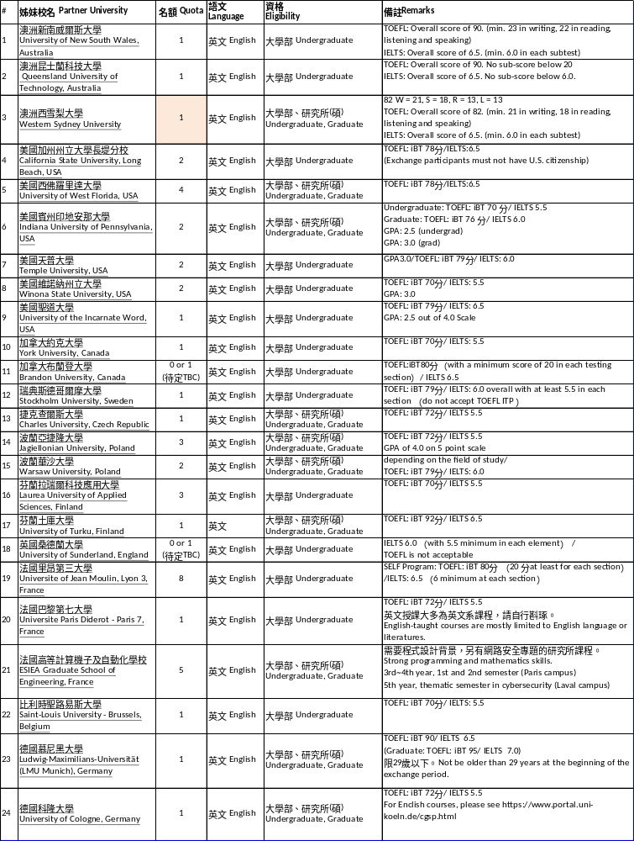
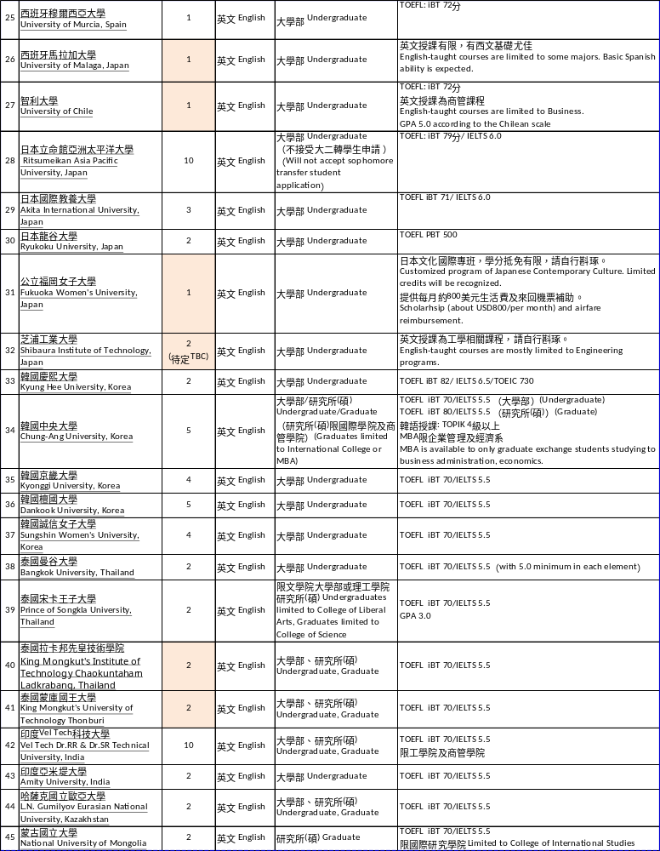

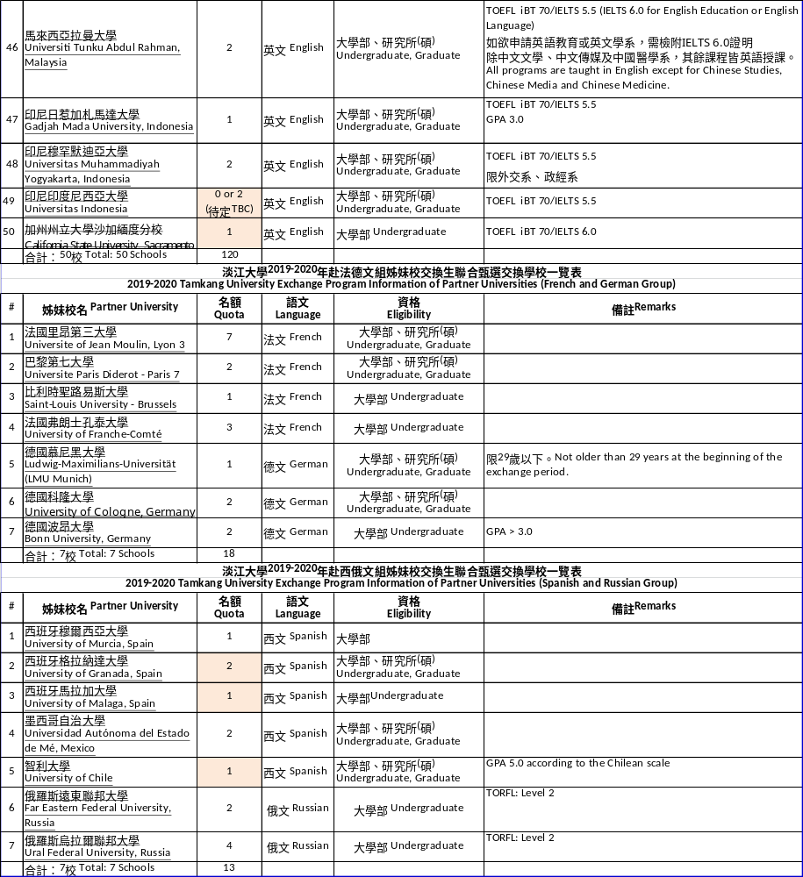

附件Attachment 5
保證書Letter of Guarantee

茲保證（請填系所年班） 學生（請填姓名）
學號： 申請本校2019-2020年國外姊妹校交換生聯合甄選，如經錄取，必將遵守下列規定，否則願意接受本校相關校規之處分：
This is to certify that student ___________ in (Department, grade, class) student ID: ________________ has applied for joint selection of foreign partner universities student exchange in 2019-2020. If accepted, will abide by the following rules, or willingly accept the relevant punishments stipulated in the school’s regulation.

- 恪遵本校及留學學校之相關法規及其給與之待遇，絕不做出任何有損兩校校譽之行為。
- I will abide by the relevant regulations of the school and exchange school and will not behave in ways that may damage both schools reputation.
- 對於本交換生計畫案公告之相關作業辦法、權益及義務，均已確實瞭解，並願配合辦理。
2. I am fully aware of the relevant operating method, right and obligation of this exchange student program and am willing to cooperate.
- 為確保交換生海外留學安全，家長與學生本人願意主動告知是否曾有身心重大疾病之就診紀錄。
3. In order to ensure the safety of students when studying abroad, parents and students should take the initiative to inform on whether there has been any suffering of major physical or mental illness treatment recorded.
- 非因不可抗力之因素，不得以任何理由放棄交換生之資格或中輟學業。研習期滿並按時返校。
4. Other than for unavoidable reasons, students are not allowed to give up their qualifications for exchange or drop out of school. Students need to return to Tamkang University after the exchange period is over.

申請人： （簽名蓋章）

家長（監護人）： （簽名蓋章）
（關係： ）

中 華 民 國 年 月 日

附件Attachment 6
交 換 生 申 請 Q & A
Q & A Student Exchange Application
- 我想申請交換生，請問我應該如何申請?
I want to apply for exchange. How can I apply?
- 請参考去年甄選辦法中的學校名單，並自行查詢各姊妹校資訊，決定欲交換的學校。可參考107學年度出國留學手冊：http://www.oieie.tku.edu.tw/zh_tw/students/learning1/plane
Please refer to the list of schools in last years’ selection and research each partner university to decide which school you would like apply. You can refer to the study abroad manual of the 107 academic year: http://www.oieie.tku.edu.tw/zh_tw/students/learning1/plane
- 請先考取欲交換學校規定的語言成績，如姊妹校沒有規定，則語言成績至少需高於申請門檻。
Please first achieve the language requirements of the exchange school. If none is provided, then scores need to be at least higher than the application requirements.
- 當年度甄選辦法將公告國際處網頁，請留意最新公告。
The selection process will be announced on the OICSA website. Please pay attention for the newest announcements.
- 請於申請截止日前，經系所學院國際處流程繳交申請資料。
Please hand in application documents to the departmentcollegeOICSA before the deadline.
- 完成報名手續後，國際處將通知您面試時間。
After the application, OICSA will inform you on when the interview will take place
- 什麼時候要提出申請?
When should you apply for exchange?
日語組 Japanese group  第一次:約2~3月(二下)  First application: about February ~ March (second semester of sophomore year)  第二次:約9~10月(三上)  Second Application: About September ~ October (first semester of junior year)  (如第一次甄選有缺額時才辦理第二次甄選)  (Second application will only happen if there are vacant spots on the first application) | 英歐語組(包括歐美、澳洲、以及以英語授課的亞洲日本姊妹校等) English and European languages group (including Europe, US, Australia, and partner universities in Asia with English-taught courses)  約11月(二上、三上)  About October ~ November (first semester of sophomore and junior year)
中文組(部分學校僅開放台灣學生申請。)
Chinese group
(please note that some schools only allow applications from Taiwanese students.)
2~3月(二下)
February ~ March (second semester of sophomore year)
9月~10月(三上)
September ~ October (first semester of junior year)
- 大三出國和交換生有什麼不同?
What is the difference between studying abroad in your junior year and being an exchange student?
Types | 辦理單位  Organizer | 姊妹校學雜費Tuition Fees of Partner University | Tamkang University Tuition Fees
Study abroad in Sophomore year | 6 Departments from College of Foreign Languages, Department of International Business, 4 Departments from Lanyang Campus | Pay full amount | 1/4
Exchange Student | Office of International Cross-Strait Affairs (OICSA) | No fees required | Pay full amount
- 語言成績申請門檻是多少分?
What is the language application requirement?
日語組Japanese Group:：  研究所學生：日本語能力檢定JLPT N1以上  Postgraduate students: Japanese language proficiency test needs to be above JLPT N1  大學部學生：日本語能力檢定JLPT N2以上  Undergraduate students: Japanese language proficiency test needs to above JLPT N2. | 英語組English Group：托福iBT 70分或IELTS 5.5(學術組)。TOEFL iBT 70 or IELTS 5.5 (Academic)  德語組German Group：德語檢定A2證明。German language proficiency test A2  法語組French Group：法語檢定B1證明。  French language proficiency test B1  西語組Spanish Group：西語檢定B1證明。Spanish language proficiency test B1  俄語組Russian Group：俄語檢定A2證明。Russian language proficiency test A2
請注意！如姊妹校另有規定門檻，則依姊妹校規定辦理。
Please note! If partner universities have other language requirements, all will go according to their regulations.
- 學業成績申請門檻是多少分?
What is the academic score requirement?
在校學業成績總平均75分以上或系百分比前40%（研究所一年級學生應檢附大學四年成績單）Applicants should obtain an average grade of 75 or above or achieves top 40% of the department (Please view “scores of all semesters”)
- 交換期間是什麼時候?
When is the exchange period?
日語組(1年)：每年4月~翌年2月(少數學校為每年9月~翌年7月)
Japanese group (1 year): Every year from April to February of the following year (few schools are September to July of the following year)
英歐語組(1年或1學期)：每年9月~翌年6月
English and European languages groups (1 year): Every year from September to June of the following year
中文組(1學期)：9月~翌年1月（上學期）或2月~7月（下學期）
Chinese group (1 semester): September to January of the following year (first semester) or February to July (second semester)
- 請問轉學生是否可憑先前學校的成績申請?
Are transfer students allowed to apply for exchange using academic transcripts from their previous school?
視姊妹校規定而定。
This will be determined in accordance to the sister school.
- 請問我可以同時申請英語組和法語組(跨組報名)嗎?
Am I allowed to apply for the English and French group at the same time?
不可以，每次僅可選擇一組報名。
No. You are only allowed to apply for one group each time.
- 推薦信我要找誰寫，有特定格式嗎?
Whom should I go to for recommendation letters and are there specific formats?
請找校內老師寫推薦信，格式不限，請使用中文或依申請語言組別撰寫。(例：英語組可繳交中文或英文推薦信)
Please ask TKU professors to write recommendation letters for you. There is no specific format. Please write in Chinese or by the language of the group, which you apply. (i.e. English group should write in English or Chinese)
- 請問要繳語言成績單或是獎狀的正本嗎?
Do you need to hand in the original copy of the language transcript or the certificate?
申請表、校內成績單、推薦信須繳交正本，其餘影本即可(語言成績證明請於面試時提供正本驗核)。
Original copies are required for the application form, school transcripts and recommendation letter. The rest can be the photocopies. (Original copies of language proficiency transcripts should be provided during the oral examination for verifications).

